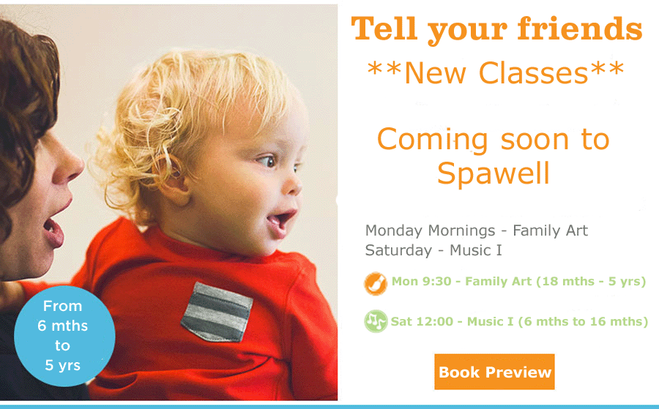

Gymboree is hosting a Virtual Party

While we are staying safe and healthy by staying home, Gymbo and his friends are thinking of you.
We thought you might like a little Gymbo time with us from home.
We will be posting short interactive videos every day on our facebook page Gymboree Play & Music Ireland and then later on our website.
Please join our Lockdown Party and watch for new video’s or activities every day from around Ireland and also from our other Gymboree friends around Europe.

